ORIGINAL RETIREMENT STAKING PLAN
The Retirement Staking Plan was devised by Grandstand's racing analyst Barry Hughes, and is rated by some professional punters and people who know racing, to be one of, if not the best staking plan they have seen.
Barry did not invent this plan by accident, it took know how and hundreds of hours of calculations to get it right.
His aim was to formulate a staking plan that could recoup all losses, and to show profits, even when a plan only breaks even. In other words, over a period of time you might have had 80 bets for 25 winners, you didn't lose, but you didn't win either. He also wanted a staking plan that could withstand long runs of outs and still achieve profits.
He did over a period of time, come up with a staking plan that did these things, but when he applied it to past results on several systems, it worked fine on some, but others, not so good.
He finally came to the conclusion that most staking plans never took into account the average price of the winners. They may work on one that has an average price winner of 5-2, and completely fail on a system with the average price winner of 5-1. The reason being, a system that does average 5-1 winners, will at some stage be more likely to go through a longer run of outs than the one that averages 5-2 winners.
The only thing he had to do now was, to work out a staking plan, with a formula that would suit all plans with different average price winners.
He finally came up with a staking plan that has a divisor, and a target, where your first bet is only 1% of your bank And as you will see he has set this staking plan up in such a way it will suit any system that shows only small profits, and can also show more than 15% at break even. It wouldn't matter if your plan averages 5-2 or 8-1 winners, or anywhere in between. You will know once you have worked out the average price winner of whatever plan you are using, how to set up and use The Retirement Staking Plan.
First. To work out the average price of the winners, ( and you should only do this after you have had more than 20 winners), you total the return of the winners, E.g. 20 winners and the total return was $100 on the TAB. Then you divide 20 into 100 = 5, so your average price winner is 4-1 as the tote return includes your dollar invested. This first step is the most important in setting up the Retirement Staking Plan, it determines your divisor, and when to bring in your safety device.
The best way to show you how to set the plan up is in the following table. First we have a divisor, which is double the average price winner of the plan you are using, say your average price winner is 3-1, your divisor would be six. We also have a tar get. Set up like this:-

First up we know the divisor will be six, double the average price winner of 3-1, your first bet is 1% of your bank, doesn't sound much, but just to show how this plan can produce over a period of time, we have started with a large bank. Now to arrive at your target, multiply your divisor by your first bet, 6 x 100 = 600. So your divisor is six, target 600, first bet 100, which is 1% of your bank, all losses are added to your target, and if you go six without a winner, then start to increase your divis or by one after each losing bet. Following is what to do when you have a run of outs.

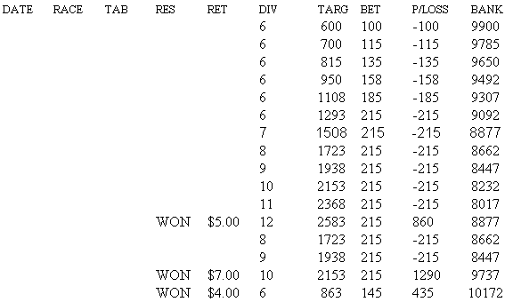

As you can see, losses were added to the target, and when we went six without a winner, we increased the divisor, if you do not, bets get out of hand and jeopardize the most important thing, the bank.
Look at the bank after six losers 9092, it could still withstand another 42 without a winner, and that is not because we started with a 10,000 bank, if you started with a 1,000 bank it would be the same, as your first bet would have been 1% = $10. By doing this, the staking plan can withstand 48 without a winner.
Now, after the 4-1, you reduced the target from 2583 to 1723, you then look back to where your target was close to this amount and you go back to where your divisor was on 8, so your next bet is 8 target 1723.
After the 6-1 winner you reduced the target from 2153 to 863, go back to the third bet when your divisor was six, you know then if this and the next three lose, you start to increase your divisor again.
Now each time the bank increases by 200, increase the target by 10, this is another safety device Barry built in to The Retirement Staking Plan. If you add 10 to your target, you only increase a bet by $1, which is only .05% of the bank increase, doesn 't sound much, but over a long period of time, and as the bets increase, you are safeguarding the bank.
When looking at the results, you will see we outlayed 2988 for a profit of 172 or 6% on turnover. What happened to the 15% or more at break even?. The reason for this is ten out of the sixteen bet's were at level stakes of 215. We will show how this ca n change when your divisor remains on six.
Now look what happens if the winners fall in a different order.

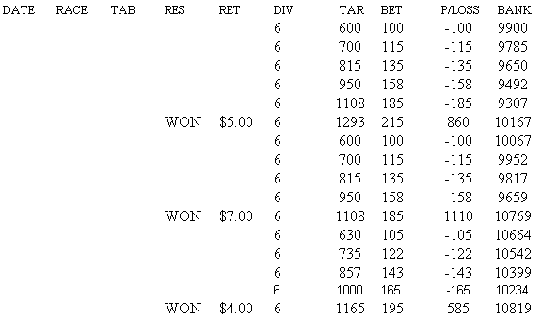

With the winner at 6-1, we increased the target to 630, and after the 3-1 winner the profit was 819 with the outlay of 2331 which represents 35% profit on turnover, outstanding results, as the plan showed no profit at level stakes,16 bets 3 winners ret urn 16.
Now the thing to remember is, work out the average price winner then double it, that becomes your divisor. E.g. 5-2 = 5, 3-1 = 6,7-2 = 7, 4-1 = 8, 9-2 = 9, 5-1 = 10. Also the divisor tells you how many losing bets to go before you increase your divisor . Start with 1% of a bank you can afford, and you have a staking plan that will show 15% at break even, and sometimes more. It will also, over a period of time as the bets increase, withstand more than 48 without a winner.
You should now be able to understand why Barry put so much work into The Retirement Staking Plan. We have quite a few clients that have not looked back since putting this Staking Plan to good use. Others have sold so called infallible staking plans for hundreds of dollars, most fail, as they will not withstand the losing runs. Barry thinks everyone should be using The Retirement Staking Plan which is offered free of charge.

